**DEPARTMENT OF ELECTRICAL & COMPUTER ENGINEERING**

**NORTH SOUTH UNIVERSITY**



JUNIOR DESIGN PROJECT

**FOOIDE**

**Submitted By:**

SIFAT ANWAR (NSU ID: 1812887642)

Md. Ahasun Kamal (NSU ID:1530187042)

**Faculty Advisor:**

Rifat Ahmed Hassan

Lecturer, Department of Electrical & Computer Engineering

**summer 2021**

**DECLARATION**

This is to certify that this Project is our original work. No part of this work has been submitted elsewhere partially or fully for the award of any other degree or diploma. Any material reproduced in this project has been properly acknowledged.

**Students’ Names & Signatures:**



SIFAT ANWAR

**_______________**

**2.**

Md. Ahasun Kamal

_______________

**APPROVAL**

We, Sifat Anwar (NSU ID:1812887642) & Md. Ahasun Kamal (NSU ID:1530187042), members of CSE299 (Junior Design) under the Department of Electrical & Computer Engineering of North South University, have worked on the project titled “FOOIDE” under the supervision of Mr. Rifat Ahmed Hassan as a partial fulfillment of the requirement for the degree of Bachelors of Science in Engineering and has been accepted as satisfactory.

**Supervisor’s Signature:**

…………………………………….

Rifat Ahmed Hassan,

Lecturer, Department of Electrical & Computer Engineering,

North South University

Dhaka, Bangladesh

**ACKNOWLEDGEMENT**

We have completed our CSE299 Junior Design project titled “FOOIDE” & we would like to express our sincere gratitude to our advisor Mr. Rifat Ahmed Hasan for his patience, motivation, enthusiasm & continuous support. His guidance throughout the duration of our project helped us to progress in a comprehensive manner. Our sincere thanks also goes to North South University for providing an opportunity in our curriculum which enabled us to have an industrial level experience as part of our academics.

**ABSTRACT**

We have created a web-based food ordering application as our project.  The web platform that we have developed is dynamic in nature, meaning we are able to add, remove or update any feature at any given time. We have created an extensive database design to ensure that the web-app can be as dynamic as possible without the need for the platform to be shut down for maintenance when we update or add new features in the future. The web platform that we have developed is based on the idea of a online food ordering System.We are planning to implement our take on most of the features and functionalities of pre-existing Foodie such as phathao food, uber eats.

Our priority is to develop a web platform which would be dynamic in nature, meaning we should be able to add, remove or update any feature at any given time.

We want our users to use  the web app to ordaring food ordering online system available to them through this project. We have named our food ordering system “**fooide**”.

**TABLE OF CONTENTS**

**CHAPTER 1**

* 1. Intoduction…………………………………………………………………….
  2. Project Definition……………………………………………………………..
  3. Project Goal …………………………………………………………………
  4. Summery……………………………………………………………………..

**CHAPTER 2**

2.1 Introduction …………………………………………………………

2.2 Existing Solutions ……………………………………………………

2.3 Summery…………………………………………………………….

**CHAPTER 3**

3.1 Database Schema for the Project ………………………………………

3.2 List of Existing Features ………………………………………………

3.3 Details of Each Feature …………………………………………………

3.4  *Use Case Diagram for the Project* ………………………………………

3.5 Technical Details………………………………………………………….

3.6 Plan for the future ………………………………………………………..

3.7 Contribution………………………………………………………………..

References ……………………………………………………………………

**CHAPTER 1: OVERVIEW**

1.1 **Introduction**

The internet gives youth freedom. They have a relevant voice because of social media & over the last decade, many platforms have become very influential. With millions of apps, websites and other platforms for people to use online food ordering system.

Pepole now a days order food in the use of online platfrom.In the covid situation this platfrom is very useful.People didn’t want to go restaurant in pandomic situation.The

Online food ordering platfrom in a very vitul for the user.People can order their chosen restaurant/hotel their favorite food in the their home.peple don’t need to go outside the home to order food .That can be a powerful feeling, and our team believes that is very important now-a -days.

User can use those system easyly to order their food.Data suggest that the popularities of various such platforms have exponentially increased. One needs to understand that without popularity, even high-quality content will get lost in oblivion.

1.2 **project defination:**

Acknowledging their ability to connect people, we decided to create a online food odering platform to try our best to solve the problem of user .They can use the app

And easyly order their food.What I propose is an online ordering system, originally designed for use in college cafeterias, but just as applicable in any food delivery industry. The main advantage of my system is that it greatly simplifies the ordering process for both the customer and the restaurant. When the customer visits the ordering webpage, they are presented with an interactive and up-to-date menu, complete with all available options and dynamically adjusting prices based on the selected options. After making a selection, the item is then added to their order, which the customer can review the details of at any time before checking out. This provides instant visual confirmation of what was selected and ensures that items in the order are, in fact, what was intended.

1.3 **Project goal:**Our project goals are follows that user can orderfood and take-out, many restaurants have chosen to focus on quick preparation and speedy delivery of orders rather than offering a rich dining experience.In this project to make the process of placing an order as simple as possible for the customer, the functionality provided the web ordering system is restricted to that which most pertinent to accomplish the desired task. All of the functions outlined above, with the exceptions of account creation and management, will be used every time a customer places an order.

1.4 **Summery:**We aimed to create online ordring food system to the user that they can get food in their home.the user take their chosen food easily in this web app.

Acknowledging their ability to connect people, we decided to create a foodie platform to those pepole who want to take home in their house.In this pandomic situation this foodie is very useful.people aslo use this app. The system then relays these orders to restaurant employees through an easy to navigate graphical interface for efficient processing.

**CHAPTER 2: EXISTING SYSTEMS & SOLUTIONS ADOPTED**

2.1 **Introduction:** traditionally there are existence of fooide:

1.share restaurent location

2.share restaurent pic

3. share food pic

Our platfrom like foodpanda,hungrnaki,etc user can easyly order food in his house.

Our web-app has been modelled after the “online food odering system” platform.

2.2 **Existing Solutions:** As can be seen in the system model diagramed above, each of the three system components essentially provides a layer of isolation between the end user and the database. The motivation behind this isolation is twofold. Firstly, allowing the end user to interact with the system through a rich interface provide a much more enjoyable user experience, particularly for the non-technical users which will account for the majority of the system’s users. In addition, this isolation layer also protects the integrity of the database by preventing users from taking any action outside those which the system is designed to handle. Because of this design pattern, it is essential to enumerate exactly which functions a user will be presented and these functions are outlined below, grouped by component.

2.3 **Summery:**We have taken inspiration from “foodpanda” online ordering food system to make this project that people can take their food easyly in the home.We have the capability to include “card payment” features in the future enabling us to transform our platform into a hybrid model. Our focus on community & restricted access also works better for data authentication, something that standalone platforms cannot ensure.

**CHAPTER 3: TECHNICAL DETAILS**

# **3.1 Database Schema for the Project**

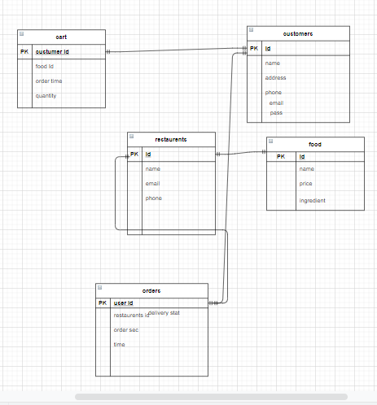

# **3.2 List of Existing Features**

1. sign-up login

2.home page

3.search

4.restaurant

5.food item

6.logout

# **3.3 Details of Each Features**

1. Sing-up and login

**Description**

New users need to Sign-Up/create an account to access the platform. An email backend has been implemented & an email host has been generated to allow a user to verify their account & to recover their account in case of forgotten password, both through email.

             Extended Use Case

**Actor:** New Users & Existing Users

**Exceptions:**

1.Too many users at a same time can cause server traffic.

2.Invalid email address.

3.Passwords don't meet the minimum requirements.

4.If the user already has an account registered with the same email address.

5.User is already logged in

**Precondition:**

Users have devices that support internet service.

**Postcondition:**

1.Successful if users can create an account successfully.

2.Unsuccessful if users can’t open the web page after signing up or getting logged in due to server error or heavy traffic.

Exception – Stay on the same page if possible.

**User Interface:**

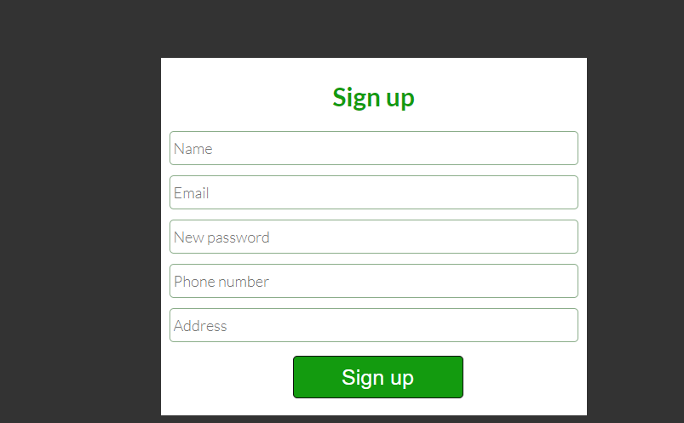

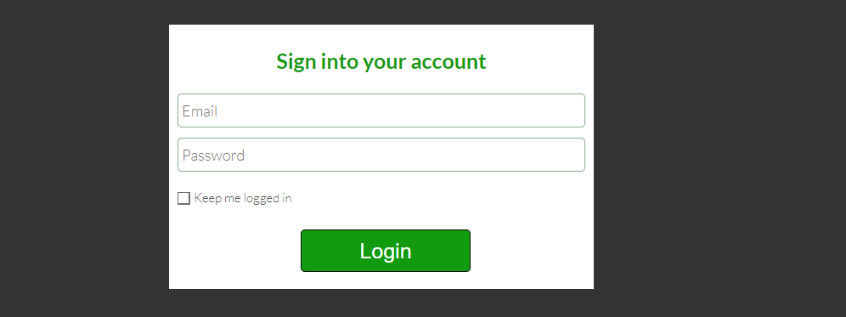

1. Search

**Description**

User can search his chosen restaurant.Users need to provide mandatory information such as name, email address in sing up.Users can use this feature to search for posts restaurent .

**Extended Use Case**

Actor: Registered Users

Exceptions:

1.No database connection.

2.Other user profile not found

Precondition:

1.Need to Sign-Up

2. Need to login

**Postcondition:**

1. Successful if search results are successfully displayed.

2.Unsuccessful if connection is interrupted or search results are not successfully displayed.

**Exception**- Display Error message

User interface:

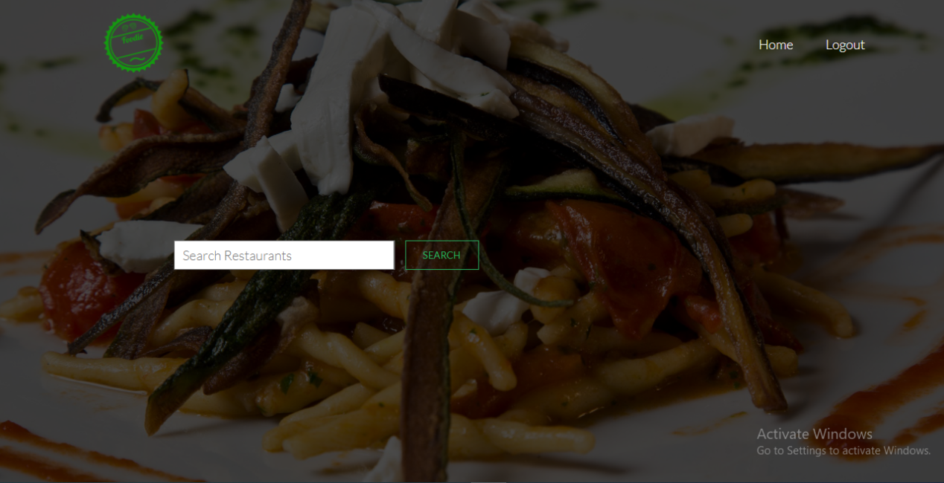

3.Order

**Description:**user can order his food in his chosen restaurent which are selected In this app.

 Extended Use Case

Actor: Registered Users

Exceptions:

1.No database connection

2.Required page not found

Precondition:

Users need to be Signed-In.

Post condition:

1.Successful if order holder are registered

2.Unsuccessful if connection is interrupted.

**Exception** – Stay on the same page if possible

User interface:

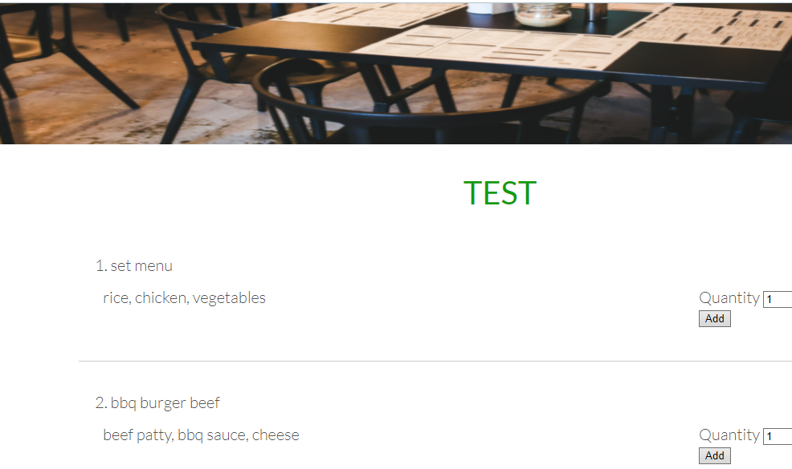

**3.4 Technical Details**

1.Operating System: Windows/ Linux/ Mac

2.Distributed Database: MySQL

3.Front-End: HTML, CSS,

4.Back-End: Php

5.Environment set-up:xampp,visual studio code

.

# **3.5 Use Case Diagram for the Project**

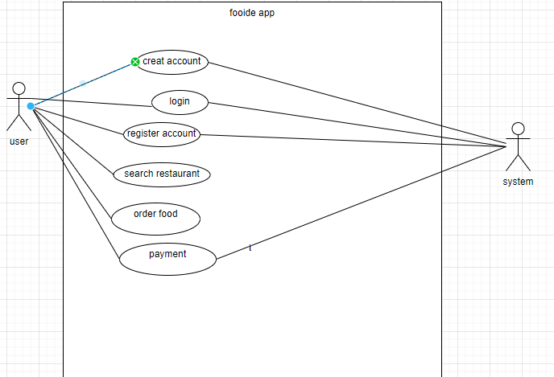

3.6**Codingstandard:**

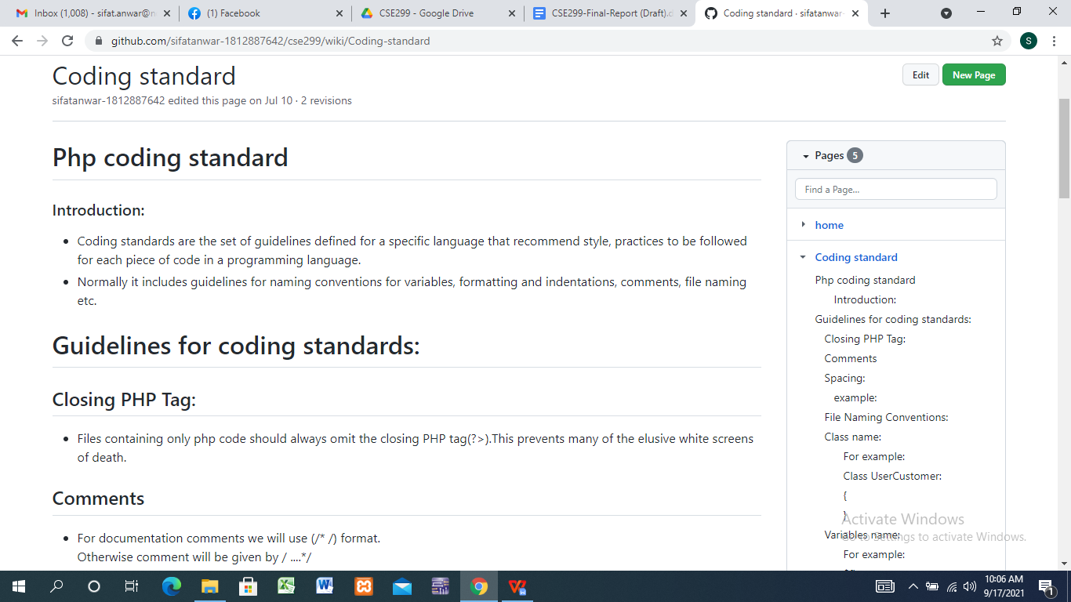

3.7 **Documentation**

We have documented our code using phpDox Documentation Tool. The presence of documentation in code helps keep track of all aspects of the code and it improves the quality of a software product. Its main focuses are development, maintenance and knowledge transfer to other developers & even non-engineers to understand the code by reading the documentation.It is the documentation generator for PHP projects.This includes, but is not limited to, API documentation.By default, phpDox uses PHP-Parser to collect information about a PHP codebase.It is a tool with which it is possible to generate documentation from your PHP source code. With this you can provide your consumers with more information regarding the functionality

3.8 **Unit Test**

We have used PhpUnit as our Unit Testing Tool. Unit testing ensures that all code meets quality standards before it's deployed. This ensures a reliable engineering environment where quality is very important. Over the course of the product development life cycle, unit testing saves time and money, and helps developers write better code, more efficiently.

3.9 **Plan for the future**

We plan to implement an actual payment gateway on our platform. We can use this updated payment feature to create two types of user accounts: a premium tier with the option.We want add online payment system such as bkash,rocket,nogod etc. We can also update the Jackpot feature to give users a promo code in case they get discount. They can use this promo code to make payment on the platform. There also rewards ponits order foods in verious restaurant.those rewards point make a big amount of discount on the next order.We also want make review system for the user that they can review those restaurant which they order food.They can review poll star and write

Write comment the restaurent.user also review the app sevice.we also update our system to user demandwe want add more restaurents in our add..We also plan to introduce a mobile-app version of this platform & we can add various new features such as discovering new restaurant through location data.This will easy for the user use to this app.

We are planning to take this project & use it as the foundation of our Senior Design Project & plan to hopefully publish a paper on the end product.

# **3.9 Contribution**

Our two-member team initially decided to divide the project into two parts of front-end & back-end development. However, since the beginning of the implementation phase, the project was divided into two sets of features. Each member was responsible for both the front-end & back-end of their feature set.Sifat Anwar(1812887642) work on fort-end and Md. Ahasun Kamal (1530187042) work on back-end.

**GitHub Project Link:** <https://github.com/sifatanwar-1812887642/cse299>

References

[1] Aacap. Social Media and Teens, American Academy of Child and Adolescent Psychiatry, 2018, www.aacap.org › Facts_for_Families › FFF-Guide.

[2] Bump, Pamela. “The 5 Types of Social Media and Pros & Cons of Each.” HubSpot Blog, 8 Dec. 2020, blog.hubspot.com/marketing/which-social-networks-should-you-focus-on.

[3]. Cooley, A. (2020, April 14). How to Tell Your Story on LinkedIn. Retrieved from www.hbr.org: https://hbr.org/2020/04/how-to-tell-your-story-on-linkedin

[4]. Rycraft, S. (2018, May 24). The Outplacement Specialists: 7 Benefits of using LinkedIn . Retrieved from www.linkedin.com: https://www.linkedin.com/pulse/7-benefits-using-linkedin-sarah-rycraft/